**Project #3:**

* Chapter 3: “Two-Layer Flows” Baines.
* **Part 1:** Numerically use the Riemann invariants (Eq 3.3.13) to get solutions for an initial smoothed tophat interface displacement.
  + Explore the parameter space shown in Fig 3.2. What happens as your initial interface is positive or negative?
  + Show examples of shocks formation.
* **Part 2:** See if the above agrees when simulating the interface in MITgcm.
* **Part 3:** In the MITgcm set up some hydraulic jumps and trace out one of the curves in Fig 3.7 for two values of ru

**Part 1:**

Here is my code for part 1:

# Project 3 Two Layer Flows

from numpy import \*

from scipy import \*

from pylab import \*

import numpy.matlib as matlib

import numpy as np

import matplotlib.pyplot as plt

from scipy.interpolate import interp1d

from scipy.ndimage import gaussian\_filter1d, gaussian\_filter

# initializing

D = 2

time\_step = 1

x = np.linspace(-100,100,1000)

t = np.r\_[0:500:time\_step]

NX=len(x)

NT=len(t)

g=9.81

rho\_2=1020

rho\_1=1000

g\_prime=g\*(rho\_2-rho\_1)/rho\_2

h=0.1 # height of one depth # Changing Variable

d\_1o=h\*D

d\_2o=(1-h)\*D

u\_1o=0#np.sqrt(g\_prime\*d\_1o)

u\_2o=0#np.sqrt(g\_prime\*d\_2o)

v\_o=u\_1o-u\_2o

#eta\_o=

# creating initial interface

boundary=np.empty((NX))

H=0.025 #amplitude of bump # Changing Variable , either positive of negative

width=10

sigma = 12

for j in range(0, NX):

if abs(x[j]) > width:

boundary[j]=0

if abs(x[j]) < width:

boundary[j]=H\*D

#boundary = H\*D\*exp(-x\*x/(sigma\*\*2))+d\_1o

#print shape(boundary)

boundary=gaussian\_filter1d(boundary,sigma)

plt.plot(x,boundary)

def calculating\_R(eta, v):

"""Calculating the Riemann invariants Eq. 3.3.13 in Baines"""

R\_p = np.arcsin((2\*eta+d\_1o-d\_2o)/D) + np.arcsin(v/(np.sqrt(g\_prime\*D)))

R\_m = np.arcsin((2\*eta+d\_1o-d\_2o)/D) - np.arcsin(v/(np.sqrt(g\_prime\*D)))

return R\_p, R\_m

def calculating\_dx\_dt(eta, v):

"""Calculating the dx/dt=C\_plus, C\_minus the wave speed Eq. 3.3.14 in Baines"""

Q=d\_1o\*u\_1o+d\_2o\*u\_2o

c\_p = Q/D + v\*(d\_2o-d\_1o-2\*eta)/D + np.sqrt((g\_prime-v\*\*2/D)\*((d\_2o-eta)\*(d\_1o+eta)/D))

c\_m = Q/D + v\*(d\_2o-d\_1o-2\*eta)/D - np.sqrt((g\_prime-v\*\*2/D)\*((d\_2o-eta)\*(d\_1o+eta)/D))

return c\_p, c\_m

def calculating\_v(R\_p, R\_m):

v=np.sin((R\_p-R\_m)/2)\*np.sqrt(g\_prime\*D)

return v

def calculating\_eta(R\_p, R\_m):

eta=np.sin((R\_p+R\_m)/2)\*D/2-d\_1o/2+d\_2o/2

return eta

v\_total = np.empty((NT+1, NX))

v\_total[0] = v\_o\*np.ones(NX)

eta\_total = np.empty((NT+1, NX))

eta\_total[0] = boundary

for j, t in enumerate(t, start=1):

eta\_j = eta\_total[j-1]

v\_j = v\_total[j-1]

R\_p\_j, R\_m\_j = calculating\_R(eta\_j, v\_j)

R\_p = interp1d(x, R\_p\_j,kind='linear',fill\_value='extrapolate')

R\_m = interp1d(x, R\_m\_j,kind='linear',fill\_value='extrapolate')

c\_p, c\_m = calculating\_dx\_dt(eta\_j, v\_j)

x\_p = x - c\_p\*time\_step

x\_m = x - c\_m\*time\_step

R\_p\_x\_p = R\_p(x\_p)

R\_m\_x\_m = R\_m(x\_m)

v\_j = calculating\_v(R\_p\_x\_p, R\_m\_x\_m)

eta\_j = calculating\_eta(R\_p\_x\_p, R\_m\_x\_m)

eta\_total[j] = eta\_j

v\_total[j] = v\_j

# Plotting

fig,ax = plt.subplots(1)

dt=15

for k in range(0, NT, dt):

plt.plot(x, eta\_total[k, :] + 0.01\*k/dt, 'b')

plt.xlabel('Distance')

plt.ylabel('Increaing time')

plt.title('Evolution of the interface in time')

ax.tick\_params(labelleft='off')

plt.savefig('h\_0.1\_u1\_0.25\_u2\_0.25\_H\_pos.pdf')

Baines Figure 3.2:

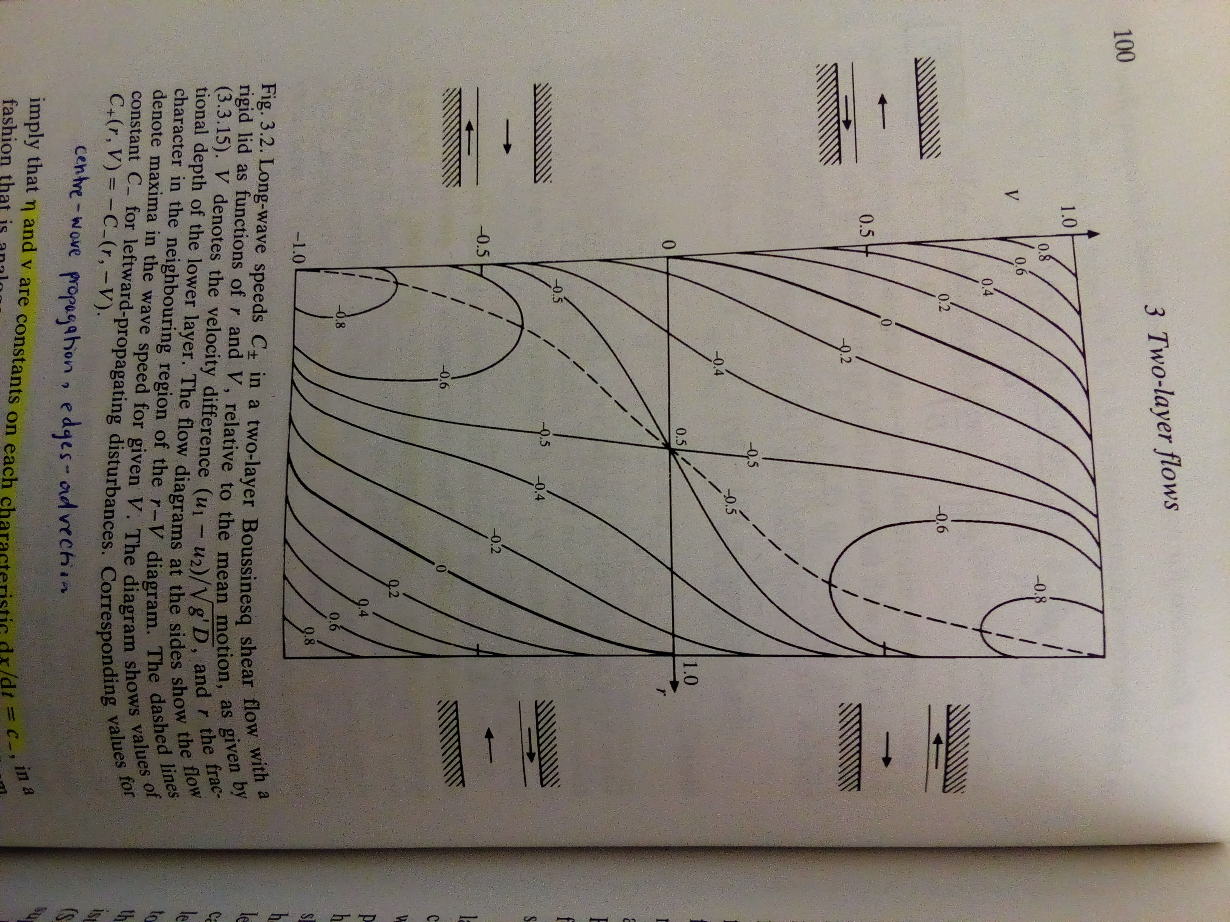

**1**

**2**

**3**

**4**

The parameter space I used for each of the 4 locations is given in the table below:

|  |  |  |  |  |  |
| --- | --- | --- | --- | --- | --- |
| Location |  | r, thickness of bottom layer | u1o | u2o | Amplitude of initial interface |
| 1 | A | 0.1 | 0.25 | -0.25 | -0.025 |
| B | 0.1 | 0.25 | -0.25 | 0.025 |
| 2 | C | 0.1 | -0.25 | 0.25 | -0.025 |
| D | 0.1 | -0.25 | 0.25 | 0.025 |
| 3 | E | 0.9 | 0.25 | -0.25 | -0.025 |
| F | 0.9 | 0.25 | -0.25 | 0.025 |
| 4 | G | 0.9 | -0.25 | 0.25 | -0.025 |
| H | 0.9 | -0.25 | 0.25 | 0.025 |

**1A 1B**

**NO NAME:h_0.1_u1_0.25_u2_-0.25_H_neg.pdfNO NAME:h_0.1_u1_0.25_u2_-0.25_H_pos.pdf**

**2C 2D**

**NO NAME:h_0.1_u1_-0.25_u2_0.25_H_neg.pdfNO NAME:h_0.1_u1_-0.25_u2_0.25_H_pos.pdf**

**3E 3F**

**NO NAME:h_0.9_u1_0.25_u2_-0.25_H_neg.pdfNO NAME:h_0.9_u1_0.25_u2_-0.25_H_pos.pdf**

**4G 4H**

**NO NAME:h_0.9_u1_-0.25_u2_0.25_H_neg.pdfNO NAME:h_0.9_u1_-0.25_u2_0.25_H_pos.pdf**

From these plots one can see that the perturbation is advected with the velocity of the thinner layer. The perturbation propagates away as an upstream wave and a downstream wave. How fast they move depend on the relative velocities.

In the case of **1A**, the upstream-propagating wave is actually slowly moving the left because of the background flow. The shape of this wave changes, a shock forms on the right hand side of the wave. The downstream-propagating wave’s shape stays the same. If the background velocities were both 0, then the upstream and downstream waves would be symmetrical and no shocks would form.

In the case of **1B**, it is almost identical to 1A, except that the shock forms on the other side of the upstream wave.

In addition one can see that location 1 and 4 (1A, 1B, 4G, 4H) are symmetric and that location 2 and 3 (2C, 2D, 3E, 3F) are also symmetric. This is as expected from Figure 3.2.

**Part 2:**

Here is my code for part 2:

Gendata.py

from numpy import \*

from scipy import \*

from scipy.ndimage import gaussian\_filter1d, gaussian\_filter

from pylab import \*

import numpy.matlib as matlib

from shutil import copy

from os import mkdir

import os

outdir='../runs/Run\_h\_0.1\_u1\_-0.1\_u2\_0.3\_H\_pos'

# 4 different regimes

#h=0.1, 0.9

#H is positive or negative

#U is in the same direction or in opposite directions

try:

mkdir(outdir)

except:

print outdir+' Exists'

try:

mkdir(outdir+'/figs')

except:

print outdir+'/figs Exists'

copy('./gendata.py',outdir)

# These must match ../code/SIZE.h

ny = 1

nx = 4\*20

nz = 100

# x direction

xt = 410e3

# dx

dx=zeros(nx)+1000

p1=np.arange(nx/2)

p2=np.flipud(p1)

p3=np.concatenate((p2,p1), axis=0)

dx=dx\*1.02\*\*p3

x=np.cumsum(dx)

x = x-x[nx/2]

with open(outdir+"/delXvar.bin", "wb") as f:

dx.tofile(f)

f.close()

# plot

if 1:

plot(x/1000.,dx)

#xlim([-10,10])

savefig(outdir+'/figs/dx.pdf')

D = 100

H=0.05 # amplitude of disturbance

width=5000

sigma = 1

h=0.1 # height of one depth

d\_1o=h\*D

d\_2o=(1-h)\*D

u\_2o=0.3

u\_1o=-0.1

# topo

topo=-D\*np.ones(nx)

with open(outdir+"/topo.bin", "wb") as f:

topo.tofile(f)

f.close()

# plot

if 1:

clf()

plot(x/1.e3,topo)

# xlim([-20.,20.])

savefig(outdir+'/figs/topo.pdf')

# dz

dz=zeros(nz)+1

z=-np.cumsum(dz)

with open(outdir+"/delZvar.bin", "wb") as f:

dz.tofile(f)

f.close()

X,Z=np.meshgrid(x,z,indexing='ij')

# Boundary interface

boundary=np.empty(nx)

for j in range(0, nx):

if abs(x[j]) > width:

boundary[j]=0

if abs(x[j]) < width:

boundary[j]=H\*D

boundary=gaussian\_filter1d(boundary,sigma)-d\_2o

Dbottom= z< -d\_2o

Dbottom2= Z < boundary [:,None]

# Temperature profile

gravity=9.81

alpha = 2e-4

g\_reduced=0.4E-3\*gravity

dT=g\_reduced/(gravity\*alpha)

Tref=np.ones(nz)\*dT

Tref[Dbottom]=0

T0 = dT \* np.ones((nx, nz)) #T0 = Tref[:,np.newaxis]\*np.ones((nz,nx))

T0[Dbottom2] = 0

# Initial Vel

U\_initial = u\_2o \* np.ones(nz)

U\_initial[Dbottom] = u\_1o

U0 = u\_2o \* np.ones((nx, nz)) #U0=U\_initial[:,np.newaxis]\*np.ones((nz,nx))

U0[Dbottom2] = u\_1o

T0=T0.transpose()

U0=U0.transpose()

with open(outdir+"/TRef.bin", "wb") as f:

Tref.tofile(f)

f.close()

with open(outdir+"/T0.bin", "wb") as f:

T0.tofile(f)

with open(outdir+"/Uin.bin","wb") as f:

U\_initial.tofile(f)

with open(outdir+"/U0.bin", "wb") as f:

U0.tofile(f)

with open(outdir+"/Ue.bin","wb") as f:

U\_initial.tofile(f)

with open(outdir+"/Uw.bin", "wb") as f:

U\_initial.tofile(f)

with open(outdir+"/Te.bin", "wb") as f:

Tref.tofile(f)

f.close()

with open(outdir+"/Tw.bin", "wb") as f:

Tref.tofile(f)

f.close()

## Copy some other files

import shutil

shutil.copy('data', outdir+'/data')

shutil.copy('eedata', outdir)

shutil.copy('data.kl10', outdir)

shutil.copy('data.mnc', outdir)

shutil.copy('data.obcs', outdir)

shutil.copy('data.diagnostics', outdir)

shutil.copy('data.pkg', outdir+'/data.pkg')

# also store these. They are small and helpful to document what we did

for nm in {'input','code','build\_options','analysis'}:

to\_path = outdir+'/'+nm

if os.path.exists(to\_path):

shutil.rmtree(to\_path)

shutil.copytree('../'+nm, outdir+'/'+nm)

Here is the matlab code to analyze the MITgcm simulation:

% Project 3 Part 2

% MITgcm Two layer flow

%% Read Data

clear;

NT=53;

data=000;

k=150;

for j=1:NT

U=0;

T=0;

U\_0=0;

T\_0=0;

U = rdmds('U',data, 'n'); % Velocity [m/s]

T = rdmds('T',data, 'n'); % Temperature [oC]

U\_0=U(:,1,1);

T\_0=T(:,1,1);

for i=2:100;

A=U(:,1,i);

B=T(:,1,i);

U\_0=[U\_0,A];

T\_0=[T\_0,B];

end

U\_0=U\_0';

T\_0=T\_0';

eval(sprintf('U%d=U\_0',j));

eval(sprintf('T%d=T\_0',j));

eval(sprintf('Time%d=data\*12.4/60/60',j));

data=data+k

end

RC = rdmds('RC', 'n'); % Z [m]

Z=RC(:,1,1);

for i=2:100;

D=RC(:,1,i);

Z=[Z,D];

end

%%

Depth = rdmds('Depth', 'n');

XC = rdmds('XC', 'n'); % X [m]

XG = rdmds('XG', 'n');

RF = rdmds('RF', 'n');

XC= XC./1000; %distance in km

%% Removing values beneath seafloor

distance= XC;

range=-1\*Z;

% for ii=1:80;

% w=find(abs(Depth(ii)-range')<5);

%

% for nn=1:50

% if nn>w(1)

% U\_1(nn,ii)=NaN;

% U\_2(nn,ii)=NaN;

% U\_3(nn,ii)=NaN;

% T\_1(nn,ii)=NaN;

% T\_2(nn,ii)=NaN;

% T\_3(nn,ii)=NaN;

% end

% end

% end

%% Figures

figure(1)

% U contours

for j=1:NT

Variable=eval(sprintf('T%d',j));

k=1;

[C h] = contourf(distance,range,Variable,k);

eval(sprintf('x%d=C(1,:)',j));

eval(sprintf('y%d=C(2,:)',j));

% Unique x's and their locations

x=eval(sprintf('x%d',j));

y=eval(sprintf('y%d',j));

[ux,~,idx] = unique(x);

% Accumulate

ymean = accumarray(idx,y,[],@mean);

movymean=movmean(ymean,3);

eval(sprintf('X%d=ux',j));

eval(sprintf('Eta%d=movymean',j));

end

%%

colormap(brewermap(21,'RdBu'))

v = VideoWriter('Run7.avi')

open(v)

for j=1:NT

Variable=eval(sprintf('T%d',j));

pcolor(Variable);

%k=[-2:0.3:2];

%contourf(distance, range, Variable,k)

axis ij;

ylim([0 100])

title('Temperature Interface')

c=colorbar; c.Label.String='T [^oC]'; caxis([0 2]);

pause(0.05)

Image(j)=getframe(gca)

writeVideo(v, Image(j))

end

hold on

ylabel('Depth [m]')

xlabel('Distance [km]');

set(gca,'LineWidth',2,'TickLength',[0.025 0.025]); set(gca,'fontsize',20)

%movie(Image)

close(v)

%%

figure (2)

for j=1:3:NT

hold on

X=eval(sprintf('X%d',j));

Y=eval(sprintf('Eta%d',j));

plot(X,5\*Y-j\*6,'b-','LineWidth',3)

axis ij

hold on

end

hold on

ylabel('Increasing Time')

xlabel('Distance [km]');

title('u\_1 = -0.1 m/s, u\_2 = 0.3 m/s, r = 0.1, \eta\_i is positive')

%title('r\_u = 0.1, u = 0.2')

%axis ij

set(gca,'LineWidth',2,'TickLength',[0.025 0.025]); set(gca,'fontsize',20);

set(gca,'YTickLabel',[])

xlim([5 120])

The first simulation I did was when u1 = u2 = 0 m/s and r = 0.1. As expected the two waves form and propagate upstream and downstream symmetrically, because there is no background velocity.

**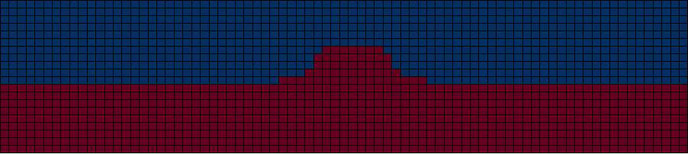**Temperature Interface (Movie)

Depth

Distance

A summary of the interface in the above movie clip is shown:

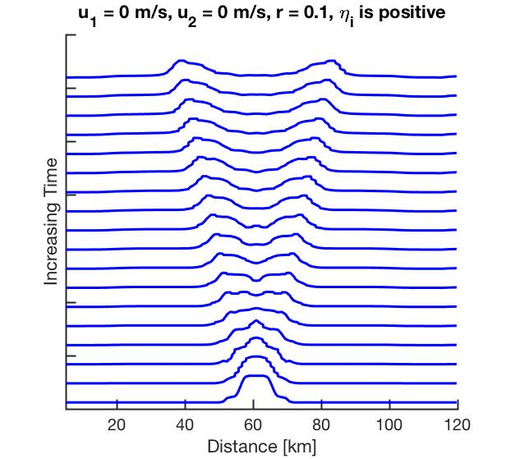

The results from the MITgcm simulation are similar to the result from the method of characteristics, except in the simulation the waves have bumpy, due to the mixing between layers. NO NAME:h_0.1_u1_0_u2_0_H_pos.pdf

More examples are shown for simulations in Locations 1 and 3.

Location 1: u1 = 0.3 m/s u2 = -0.1 m/s and r = 0.1.

Temperature Interface (Movie)

Depth

**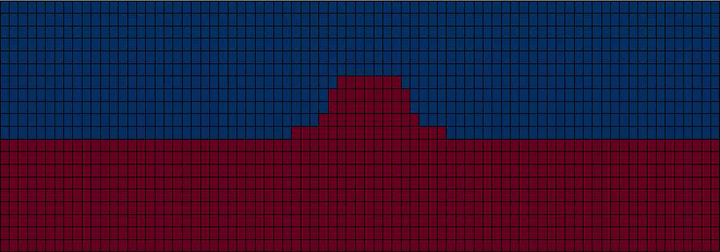**

Distance

A summary of the interface in the above movie clip is shown:

**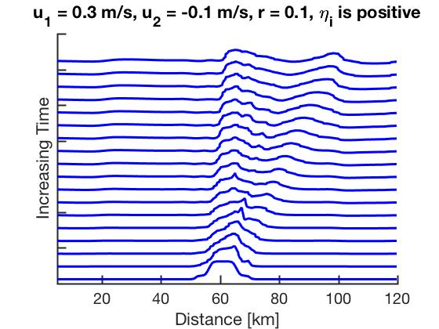**

Location 3: u1 = 0.3 m/s u2 = -0.1 m/s and r = 0.9.

Temperature Interface (Movie)

Depth

**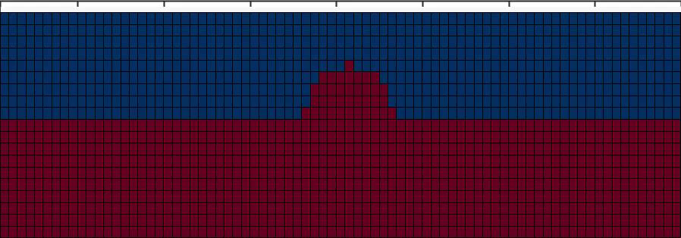**

Distance

A summary of the interface in the above movie clip is shown:

**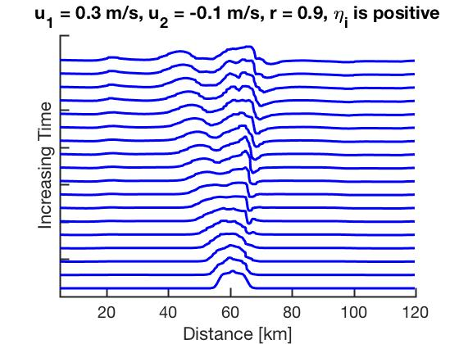**

These simulations are similar to the results for the method of characteristics. You can slowly see the two waves being created, and the shock forming on either the upstream wave. Again, the perturbation is advected with the velocity of the thinner layer.

**Part 3:**

For the hydraulic jump I used the same gendata.py, except this time the topography has a tophat bump.

Here is the addition for the gendata.py code relating to the topography:

# topo

topo=-D\*np.ones(nx)

width=5000

sigma = 1

for j in range(0, nx):

if abs(x[j]) > width:

topo[j]=0

if abs(x[j]) < width:

topo[j]=0.7\*d\_1o

topo=gaussian\_filter1d(topo,sigma)-D

plt.plot(x,topo)

topo[topo>0.]=0.

I ran this simulation at ru = 0.1, 0.3 and at many different initial velocities.

Baines Figure 3.7:

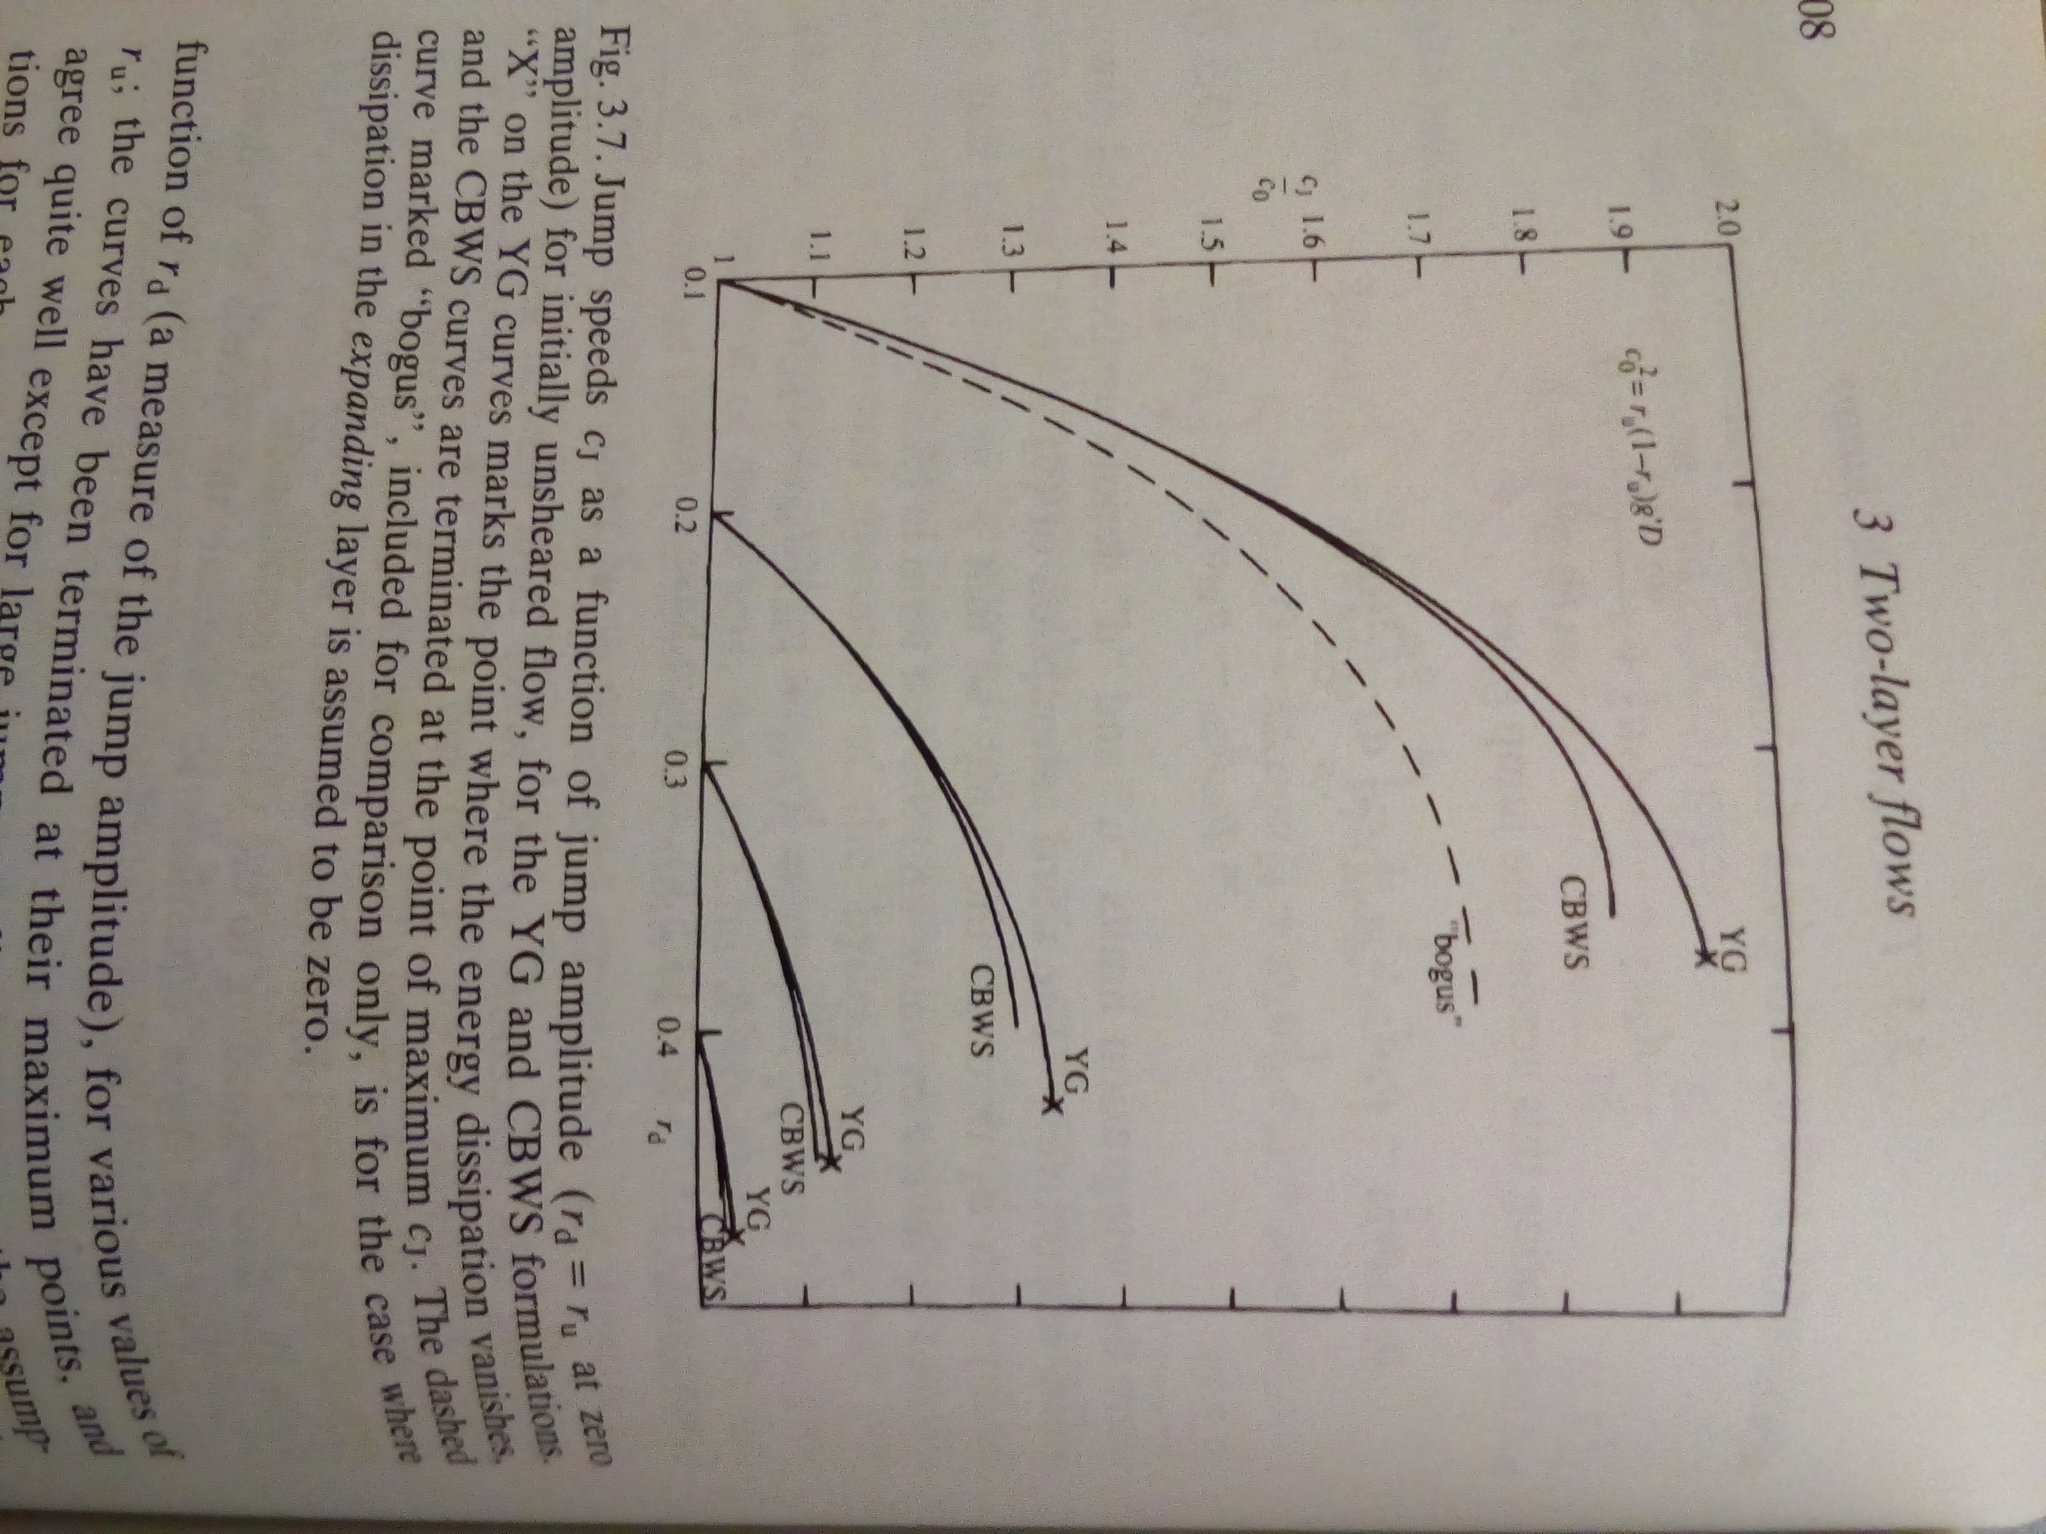

I have attached the code that let me theoretically recreate Figure 3.7:

rho1 = 1025;

rho2 = 1026;

r\_u = 0.1;

r\_d = [0:0.01:0.5];

%YG formulation %Eq. 3.5.11 of Baines

top = (r\_u + r\_d)./2;

bottom = (r\_u./r\_d) + (rho2.\*(1-r\_u).\*(r\_u+r\_d)./(rho1.\*(1-r\_d).\*(2-r\_u-r\_d)));

CJ\_YG = sqrt(top./bottom);

%CBWS formulation %Eq. 3.5.12 of Baines

bottom2 = (r\_u./r\_d) + ((rho2./rho1)\*(r\_u+r\_d-2.\*r\_u.\*r\_d)./(2.\*(1-r\_d).^2));

cJ\_CBWS = sqrt(top./bottom2);

scale = sqrt(r\_u.\*(1-r\_u));

% Very rough estimation of C\_J and r\_d from MITgcm simulation

c=[0.105,0.22,0.3,0.35,0.45];

r=[1.1,1.4,1.7,1.05,1.2];

%Figure 3.7 of Baines

plot(r\_d, CJ\_YG/scale, 'b','LineWidth',3)

hold on

plot(r\_d, cJ\_CBWS/scale, 'r','LineWidth',3)

hold on

plot(c,r,'kd')

legend('YG', 'CBWS');

xlim([0.1 0.5])

ylim([1 2])

ylabel('C\_J/C\_o')

xlabel('r\_d')

set(gca,'LineWidth',2,'TickLength',[0.025 0.025]); set(gca,'fontsize',20);

In each simulation I made very rough estimates of the jump speed and rd. The jump speed was estimated by looking at two time snap shots and calculating the change in jump position. The jump speed was then scaled by c0. rd was calculated as the maximum interface value.

Below is an example of the results I got for the hydraulic jump. A jump of height rd forms (this depends on the initial velocity) and moves at the jump speed upstream.

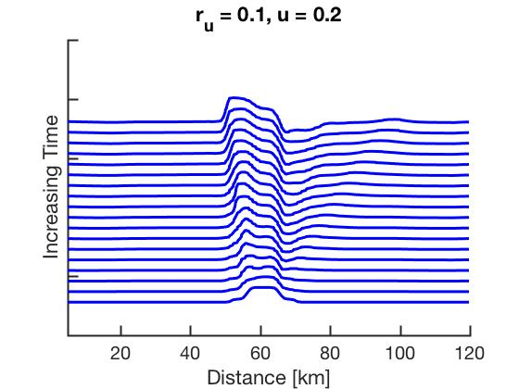

A summary of my results is shown:

**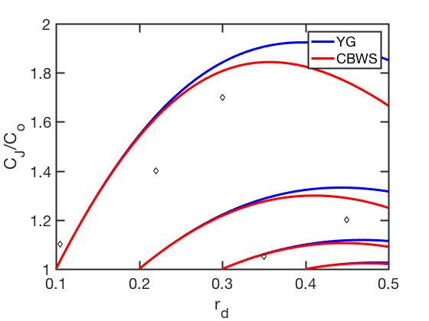**

Although the values match the trend, my estimations are CJ and rd were very coarse. I need to a more accurate way to estimate the jump speed, before making any assumptions about the YG and CBWS formulations. In a couple simulations CJ/C0 was less than 1, which did not match Figure 3.7 at all.